Hi Guys, I am so excited to work with you this semester! I created to document to help you get started using Git Hub. Follow these instructions to get all set up, and feel free to message me if you have any questions ☺

P.S. None of this is mine. I appropriated this from the EDA class here at Duke and other online sources.

1. Clone the GitHub Repository
   1. On GitHub, navigate to the Code tab of the repository.
   2. On the right side of the screen, click Clone or download.
      1. A screenshot of a computer

         Description automatically generated
   3. Click the Copy to clipboard icon to the right of the repository URL.
   4. Open RStudio on your local environment.
   5. Click File, New Project, Version Control, Git. (Ignore parts D and E in pictures below)
   6. Paste the repository URL and enter TAB to move to the Project directory name field.
      1. 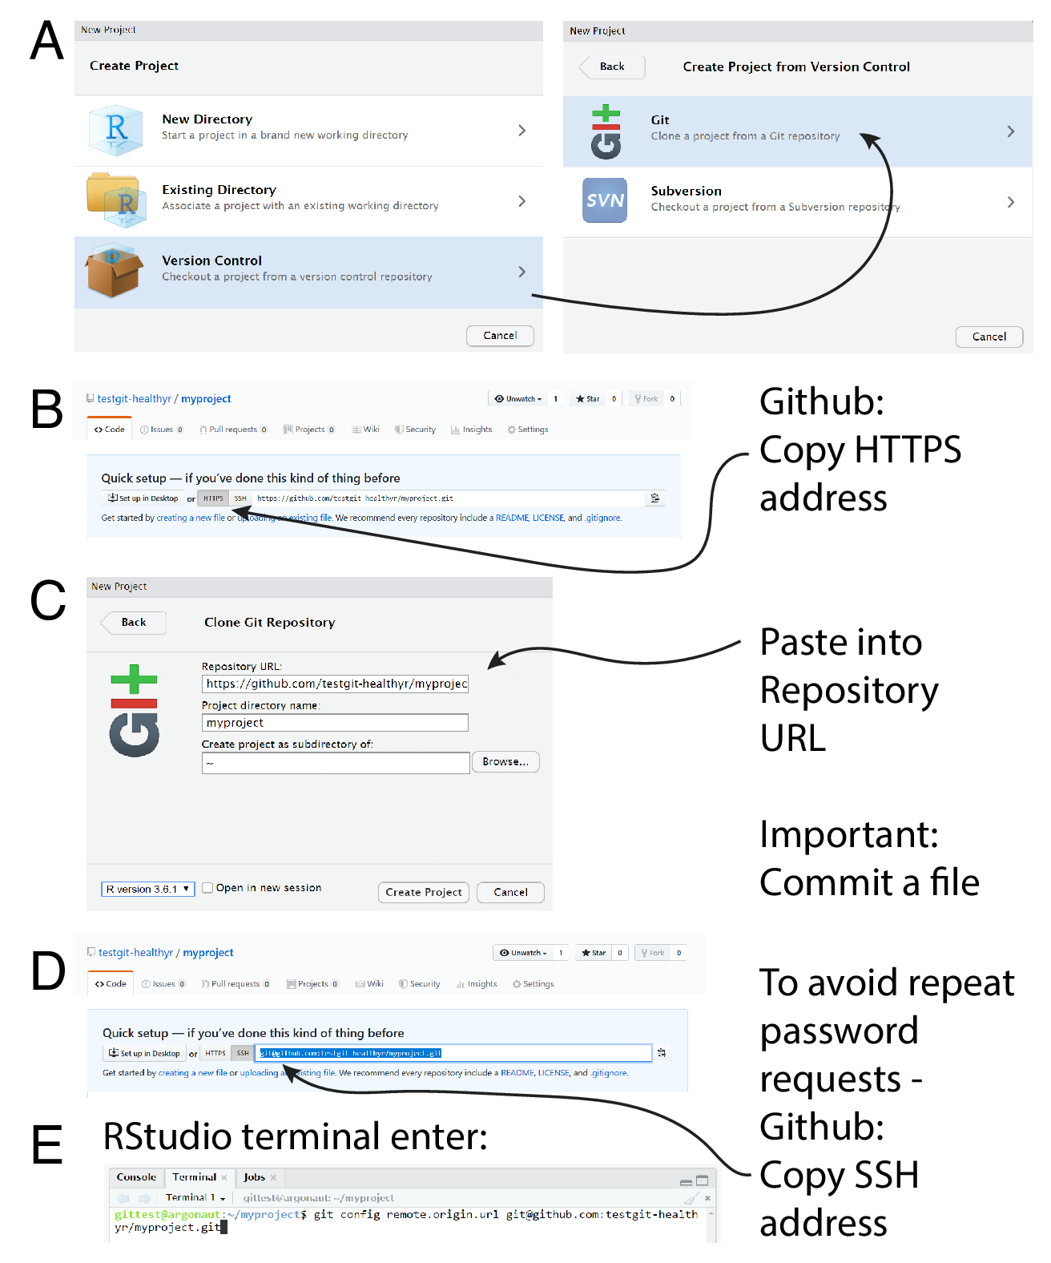
   7. Click Create Project.
2. Login to GitHub on Rstudio
   1. Once you have forked the repository and created your new project, you can enter a personal token that will substitute for logging into Gitub on Rstudio.
   2. Activate the **Terminal** window in RStudio.
   3. At the $ prompt type type the following to ensure it is working properly:
   4. git --version

This should return the version of Git installed on your machine, e.g. git version 2.39.0.  
*If you get an error here, contact an instructor as your Git software is not operational.*

* 1. Again, at the $ prompt type (replacing your own Git username and email with the placeholders below:
  2. git config --global user.name "Your Name"
  3. git config --global user.email "your.email@gmail.com"

git config --global --list

* 1. “That last line reports what you saved as your global user name and user email variables. If you entered them incorrectly, just run the command again with the corrected info.”

1. Create Acess Token
   * 1. Navigate to this link: <https://github.com/settings/tokens>

*Alternatively you can find the setting via the following sequence while logged into your GitHub account:*

* + 1. *Click the icon associated with your profile in the extreme upper right of the page to open the Profile menu.*
    2. *Select Settings from the dropdown, or just click on this link:*[*https://github.com/settings/profile*](https://github.com/settings/profile)
    3. *The very last entry on the list on the left-hand side is Develper settings. Click that.*
    4. *Then click on Peronal access token from the left-hand list on that page, and then select Tokens (classic)*
  1. From the Generate new token dropdown, select Generate new token (classic). You may be asked to authenticate again.
  2. In creating the token, use the following settings:
     1. Add a **note** that will help you identify what this token will be used for (in case you want to delete it). For example: “ENV 859 Class”.
     2. Set the **expiration** date to be sometime after the semester is over.
     3. For **scopes**: check the following boxes:
     4. repo
     5. workflow
     6. user
  3. Finally, click Generate token.
  4. **Copy the token somewhere you’ll be able to find again** as you’ll need this string to link any new RStudio session to your GitHub account. (I find sending myself a Slack message with this token to be pretty good.)

1. Now time to enter this in Rstudio
   1. Activate the **Console** window in RStudio.
   2. Install the “usethis” package with the following command:
   3. install.packages("usethis")
   4. Then run following command to save your PAT as a Git credential:
   5. gitcreds::gitcreds_set()

This will start a set of prompts asking you to save your PAT as an encrypted file on the local machine.